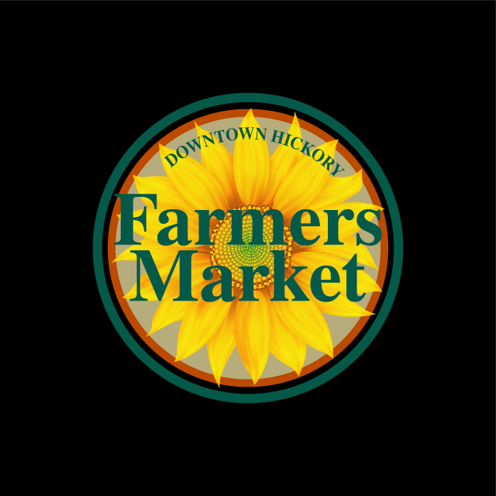
Hickory Farmers Market 2022 Vendor Application
APPLICATION DEADLINE for OPENING season – February 12
*Indicates Required Fields – Please print or type legibly.
*Farm/Business Name_______________________________*Personal Name_________________________
*Physical address____________________________*City_____________*State___________*Zip___________
Mailing or P.O. Box_______________ City________________ State____________ Zip____________
*Telephone____________________ Cell phone____________________ County________________________
Email_________________________________ Website/Facebook_____________________________________
In 25 words or less, describe your Farm/business for our website____________________________________
___________________________________________________________________________________________
*Certificate of Registration #______________________________________________________
A copy of your Certificate of Registration (aka Sales & Use Tax #) or Tax Exempt # is required, by NC Tax Laws, to be displayed at your booth. Google NC Department of Revenue to apply for your Certificate of Registration #. Tracking/Confirmation/Pending #’s are acceptable until your business receives the actual # via mail. *ONLY FOR APPROVED RETURNING VENDORS- New applications only being accepted for 100% producers. Do you grow/raise/make your own products? Y ___ N___ *What percentage do you produce for the entirety of the season? _________ One (1) sign only, designating your status, will be issued to your farm/business based on this application. This sign is not interchangeable and will commit you as a “100% producer” or “partial reseller.” If you purchase any % from another source, please provide the name of farm/business & all contact information:__________________________________________________
Specific products to be sold at the Farmers Market (please attach additional pages if necessary) –
_________________________________________________________________________________________
*Vendor fees are due MONTHLY by the 1st week of each month. Payments not made by the 15th will be charged a late fee of $20 and may result in market suspension. BOOTH SITES are 9x9 ~ the market is located under the Sails in downtown Hickory and the Sails are not waterproof. Questions? Please contact Market Manager at hickoryncfarmersmarket@gmail.com *best method (or 828-308-6508)

***Please circle your vendor preference: *Circle: Site rental only - daily $12 (Wednesdays) (does not include site parking space) or
(Parking in unrestricted City lots ONLY) $17 (Saturdays) ================================================================================== Site rental with parking - daily $20 (Wednesdays) (inclusive of site parking space or extended sites) or
(Parking space assigned at/with booth) $25 (Saturdays)
Less than full month attendance $35/visit
Required Certifications
Please include a current/valid copy of the required certifications – Acidified Foods Manufacturing School (aka “Pickling School”), meat handler's registration, grower’s certification, dairy inspection, nursery inspection, Health Department inspections and sanitation grade certificates by APRIL 5th. Kitchen sanitation grade certificates must be displayed at your booth.
Water & Electricity
City water (faucet) is available at the public restrooms. Electrical outlets are provided; bring a drop cord to ensure proper plug in. SAMPLES ARE ENCOURAGED and cooking is allowed with appliances that DO NOT use propane, create a flame or fry foods. For example; electric griddles/crock pots/microwaves are allowed.
Returning Vendor
The HFM is an evolving market. An Application Review Committee of the Board of Directors reviews new & returning applicants on an annual basis. Any changes/additions must be explained on your current application. Each market day is considered as a separate market (Wednesday and Saturday) with vendor and customer base differences. Thus, applications are processed by market days – not as a whole. Most notably – there are NO GUARANTEES OF ACCEPTANCE and/or booth assignment/location for the current year.
1. How many years have you participated in the Hickory Farmers Market?
New Vendor - Please use a separate sheet if necessary. This is your opportunity to “sell yourself!”
General Background Information:
- How do you currently sell your products?
- Do you sell at other farmers markets in the area? If so, which ones and for how long?
- Have you ever visited a Wednesday or Saturday Hickory Farmers Markets?
- Is there anything else you want us to know about your products, experiences, or plans?
- Do you have a storefront? If so, where?
Prepared Food Vendor Background Information:
- How long have you produced the items you want to sell?
- In reviewing your application, would you be willing to bring us a sample of your work?
- What makes your goods different from what already exists at our market?
- Do you plan on using any local ingredients? (If so, please describe how and from where you source your ingredients)
- Have you ever worked in a professional kitchen? (Please describe your past kitchen experience)
Farmer Vendor Background Information:
- How long have you been farming?
- How much area do you have in production?
- How long have you been producing these products?
- What percent of the products you intend to sell are grown on your farm?
Market Dates
*Please indicate what days/months you are applying for to participate in the HFM.
The regular market season opens the 3rd Saturday of April (4/16) and closes on the last Saturday of November (11/26)
Days/hours of operation – April thru October: Wednesday 10am – 2pm / Saturday 8am – 1pm
November -mid-April schedule: Saturdays ONLY 10am – 1pm & NO OPENING BELL
 | Wed. | Sat. | Planned  Absent(s) |  | Wed. | Sat. | Planned  Absent(s)
April |  |  |  | August
May |  |  |  | September
June |  |  |  | October
July |  |  |  | November

NOTE: The market is CLOSED the 2nd Saturday of October (10/8) for Oktoberfest
Are you interested. In attending the Winter Market as well?

Waiver: I (we) hereby relieve the Hickory Farmers Market (also known as HFM) its agents and employees from any and all liability for any damage, loss, injury or costs associated with or arising from the applicant’s use and presence at the HFM; and furthermore, I (we) agree to indemnify and hold the City of Hickory harmless from all claims, costs, and actions occasioned by me for the use and presence at the HFM.
Rules: I (we) have read the HFM Rules and Regulations and Check List for the current year and agree to comply the Rules and Regulations of this agreement and those of the City of Hickory (parking, ordinances, fire regulations, tent weights, etc.) I (we) understand that I (we) must read the Rules and Regulations (inclusive of penalties) and the HFM Check List at www.hickoryfarmersmarket.com and/or request a written copy from the HFM manager in writing. I (we) understand that by not abiding by the established Rules and Regulations and Check List, I (we) will forfeit participation as a vendor, with no refund of pre-paid fees. I (we) agree to allow the market manager or HFM affiliates to visit/tour your farm or business.
*Please include the required certifications and a $35.00, non-refundable application fee (check/money order) made payable to Hickory Farmers Market, and mailed to:
HFM, P.O. Box 45, Hickory, NC 28603-0045.
The APPLICATION DEADLINE for opening season is February 12. Notice of your application status will be emailed to the address you have provided.
I have downloaded, read and agree to abide by DHFM Rules and Regulations.
_________________________________________ ______________________________________
Applicant(s) Signature Date

